« ANALYSING QUALITATIVE DATA »

The analysis grid for the interviews we propose is based on the thematic analysis [Paille and Mucchielli, 2011]. A table is drawn up for each theme covered (e.g. the positive points concerning the method). We use a three-column table. A first column shows the sub-themes, the second column shows the associated verbatims and the third column shows the code of participants and/or the number of participants who discussed the sub-theme. The themes and sub-themes are associated with the 'title' styles of Word (Figure 1). Subsequently, a table of contents is drawn up with the title of the themes and sub-themes, this table of contents is used to write the data analysis. Then, a synthesis must be written for each of the themes. (Another Creswell reference, Mixed qualitative/quantitative methods researchs.)

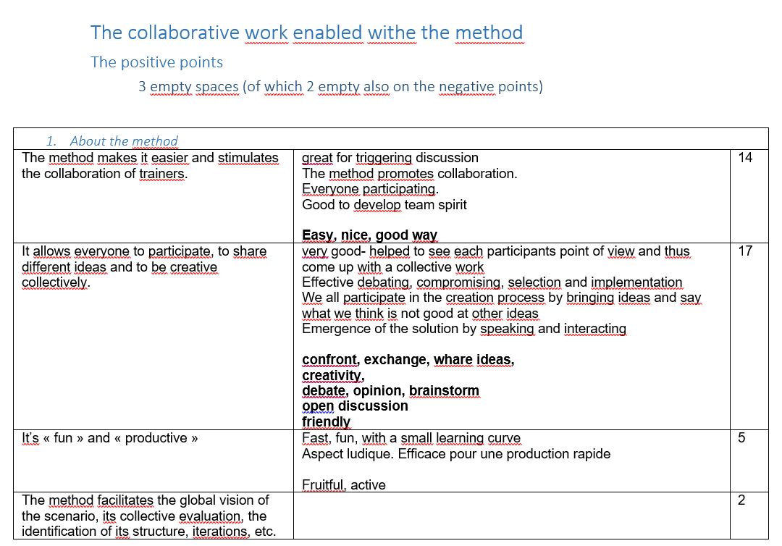
Figure 1: Example of a table for analysing interview verbatim
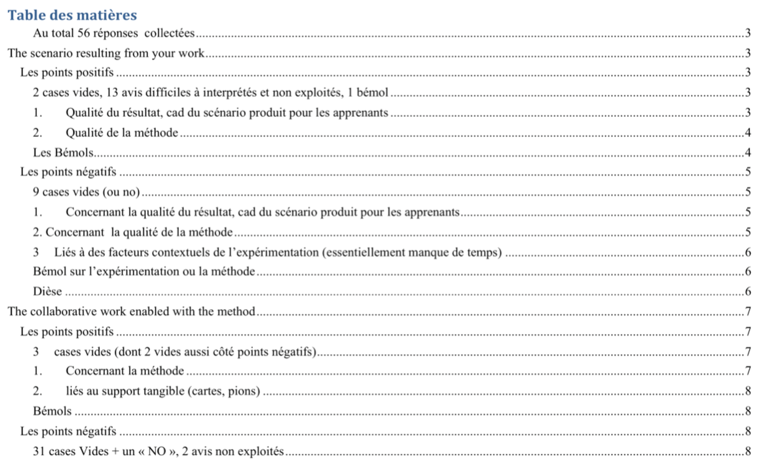
Figure 2: Table of contents with themes and sub-themes for a thematic analysis of the interviews, built with word styles

