When: This document must be done at the beginning of your thesis, and then you should come back on it every week to see what you need to do or what is already done.

Why: It allows you to structure and synthesize your research, and organize the chapters of your manuscript.

Who: It’s to be written by the PhD student.

Contributions: It’s a support for discussion between doctoral student and thesis supervisor.

This guide includes a combination of two tools: the ishikawa diagram to sequence your thesis work and the Kanban to follow it. These are two tools provided by the quality approach.

On page 4, we give an example of the use of these two tools in the project management.

Instructions :

How to do the Ishikawa diagram? (have a look page 2)
  - In the coloured frames, put the main action themes of your thesis (for example, "Literature review "). It’s normal that you don’t have a synthetic vision of the thesis when you start, but it’s important to project yourself and to complete, if possible, the 6 frames. With the progress in the thesis, the frames can be renamed.
  - In the white boxes, specify by branch the main actions (for example, for the branch "Literature review", "to obtain reference literature", "to enrich the literature", "to review the literature").
  - It’s recommended to put nouns in coloured frames and verbs in white frames.
  - The «» symbol can be added next to one or more white frames to show the requirement to iterate.

How to do the Kanban board ? (have a look page 3)
  - Split each blank frame into action tasks as accurately as possible (e.g., "Read Article XXX"). You can write them on PostIt.
  - Each PostIt must contain the name of the task, a reference to the color frame (color stickers, color PostIt, frame number, etc), the name of the person(s) involved in the task and the dead line.
  - Put the PostIt at the intersection of the corresponding colored line and the "To do" column.
  - When you are executing a task, advance the PostIt in the "Doing" column.
  - When a task is finished, advance the PostIt to the "Done" column.
  - If the deadline for doing this task has expired, move the PostIt to the "Too late" column.
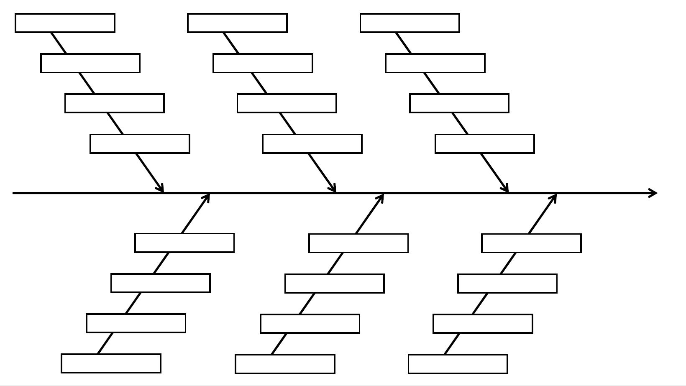
Steps | To do | Doing | Done | Too late

Example for the project APACHES :

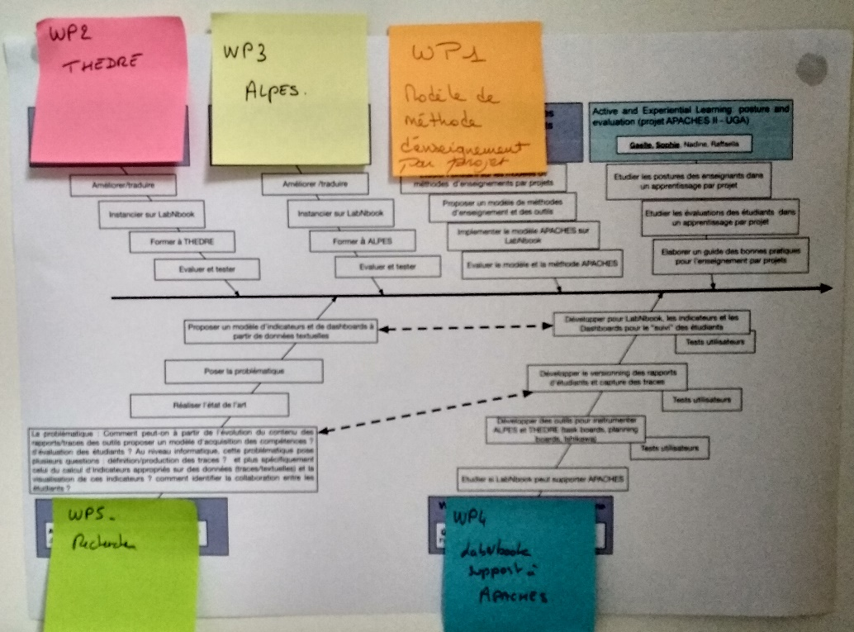
Example of an adapted Ishikawa diagram from the APACHES project

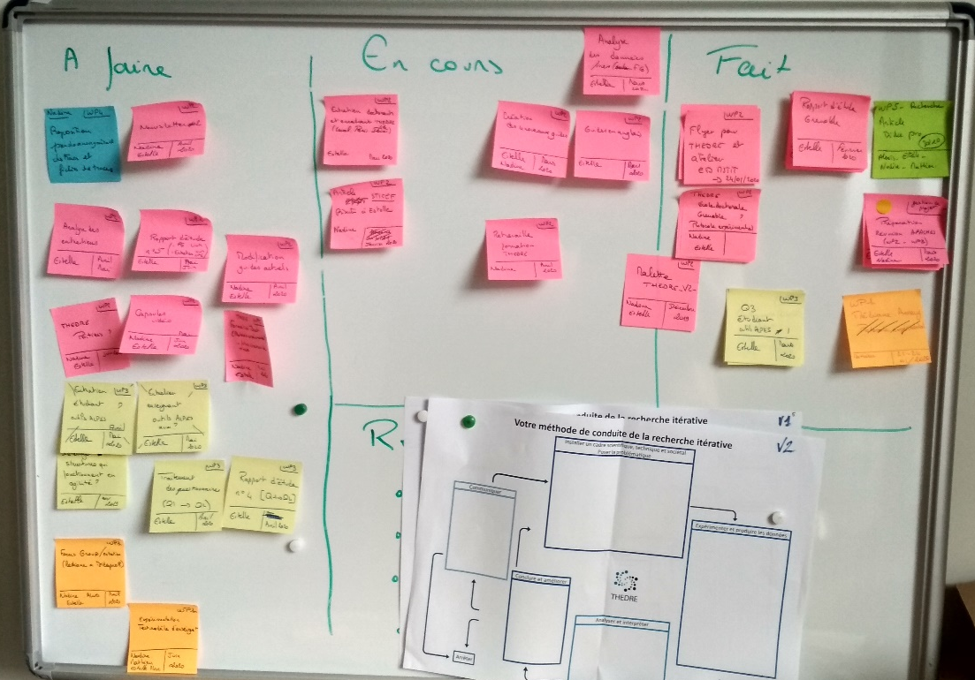
Example of an adapted Kanban board from the APACHES project

